State level logic model: Reducing and preventing youth tobacco use

Inputs |  |  |  | Activities
 | 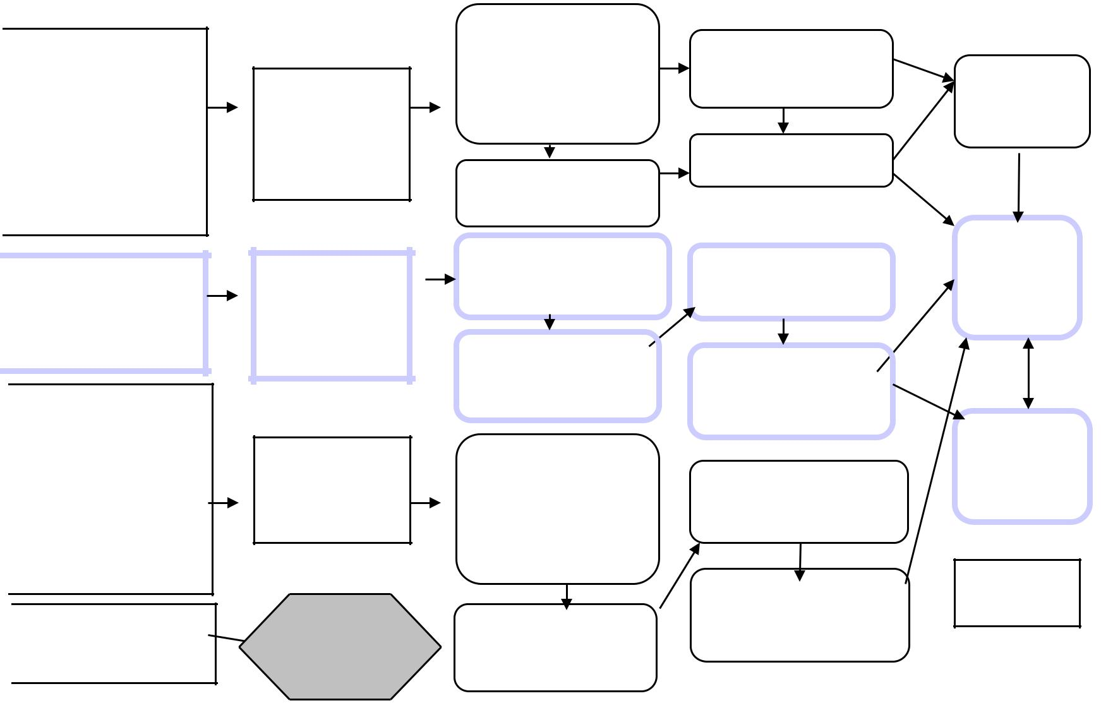 |  |  | Promote community
 |  |  |  | involvement in restricting
 |  |  |  | tobacco access to youth
Coalition |  |  |  | • Establish
 |  |  |  | baseline of
Members
 |  |  |  | current practices
 |  |  |  | • Inform/educate
 |  |  |  | • Eliminate self-
 |  |  |  | service
 |  |  |  | • Facilitate active
Funding
 |  |  |  | enforcement of
 |  |  |  | laws
Partners |  |  |  | Facilitate youth involvement
•Local |  |  |  | in policy change
• Regional |  |  |  | • Recruit youth
 |  |  |  | • Involve
•State
 |  |  |  | youth/adults
 |  |  |  | • Educate
 |  |  |  | Promote school and
Researc |  |  |  | community based prevention
 |  |  |  | programs and policies
h and |  |  |  | • Establish
best |  |  |  | baseline of
practices |  |  |  | existing
 |  |  |  | resources
 |  |  |  | • Educate
 |  |  |  | • Assist with
 |  |  |  | planning and
 |  |  |  | implementing
 |  |  |  | programs/service
 |  |  |  | s
 |  |  |  | Promote youth cessation
 |  |  |  | services and
 |  |  |  | policies

Reach

Community

Parents,

Caretakers

Law enforcement

Retailer

Health Department

Community org,

Businesses

Policy makers

Adults

Youth serving org

Youth

Schools

Community

Families

Youth serving org

Youth

See Treating

Tobacco

Addiction Youth

Logic Model

Short

Increased awareness of need to eliminate youth access to tobacco products, including tobacco industry tactics, laws, noncompliance

Increased commitment to eliminate access/sources

Increased knowledge and skills in participating in policy change

Increased commitment by youth and adults for youth to participate in policy change

Increased knowledge about tobacco dependence; benefits and options for youth prevention (e.g, CDC guidelines, school-family initiatives)

Increased commitment to adopt effective programs/policies for youth prevention

Outcomes - Impact

Medium

Increased compliance and enforcement of laws and policies

Decreased supply to minors

Increased # of youth actively engaged in policy change

Increased adoption of policy changes that involve youth in the change process

Increased # of effective prevention programs or policies adopted

Increased # of youth participating in prevention programs

Long

Decreased access to tobacco for minors

Social norms less supportive of youth tobacco use

Delayed average age at first use; reduced initiation

Reduced morbidity and mortality

